上海健康医学院

《健康数据挖掘》
实验报告

院（系）: 医疗器械学院
课 程: 健康数据挖掘
专业班级：22级数据科学与大数据技术2班
学 号： B22040302020
学生姓名： 周雨晴
指导教师： 任和

实验四

OneR实验
运行代码：
- # OneR算法实现
- import numpy as np
- from sklearn.datasets import load_iris
- # 加载iris数据集
- dataset = load_iris()

- print(dataset.DESCR)

结果截图：
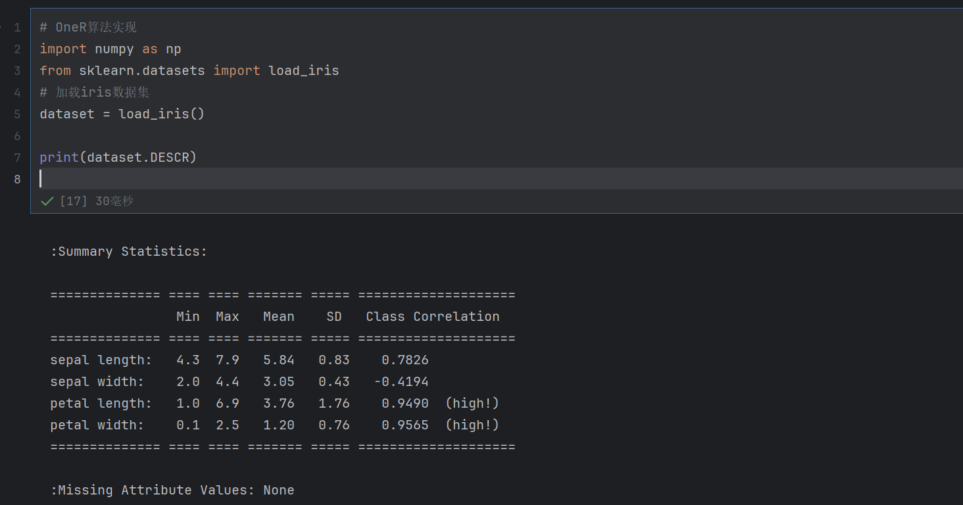

运行代码：

- # 加载iris数据集中的data数组（数据集的特征）
- X = dataset.data
- # 加载iris数据集中的target数组（数据集的类别）
- y_true = dataset.target
- # 计算每一项特征的平均值
- attribute_means = X.mean(axis=0)
- # 与平均值比较，大于等于的为“1”，小于的为“0”.将连续性的特征值变为离散性的类别型。
- x = np.array(X >= attribute_means, dtype="int")

- n_samples, n_features = X.shape

- print(n_samples, n_features)

结果截图：
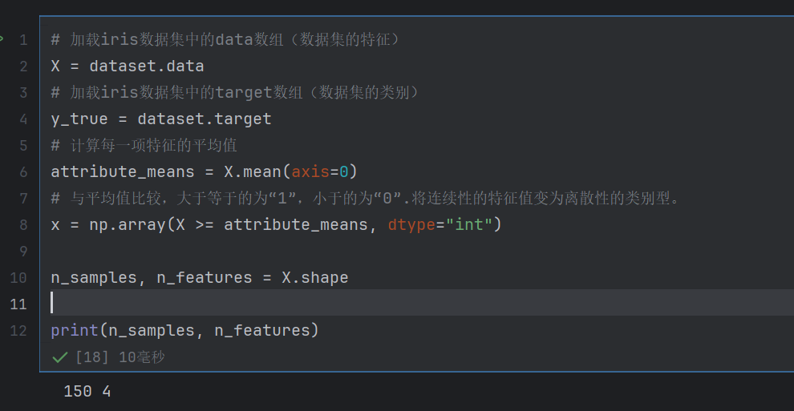

运行代码：
- from sklearn.model_selection import train_test_split
- x_train, x_test, y_train, y_test = train_test_split(x, y_true, random_state=14)

- from operator import itemgetter
- from collections import defaultdict
- # 找到一个特征下特定值对应的最可能类别及错误数
- def train_feature_class(x, y_true, feature_index, feature_values):
- num_class = defaultdict(int)
- for sample, y in zip(x, y_true):
- if sample[feature_index] == feature_values:
- num_class[y] += 1
- # 按类别出现次数排序，找出最频繁的类别
- sorted_num_class = sorted(num_class.items(), key=itemgetter(1), reverse=True) # 修正itemgetter参数错误
- most_frequent_class = sorted_num_class[0][0]
- # 计算错误数（非最频繁类别的样本数总和）
- error = sum(value_num for class_num, value_num in sorted_num_class if class_num != most_frequent_class)
- return most_frequent_class, error

- # 训练单个特征，返回该特征下各值的预测类别及总错误数
- def train_feature(x, y_true, feature_index):
- n_sample, n_feature = x.shape
- assert 0 <= feature_index < n_feature
- values = set(x[:, feature_index]) # 该特征的所有可能值
- predictors = {}
- errors = []
- for current_value in values:
- most_frequent_class, error = train_feature_class(x, y_true, feature_index, current_value)
- predictors[current_value] = most_frequent_class
- errors.append(error)
- total_error = sum(errors)
- return predictors, total_error

- # 找到所有特征下的各特征值的类别，格式就如：{0：({0: 0, 1: 2}, 41)}首先为一个字典，字典的键是某个特征，字典的值由一个集合构成，这个集合又是由一个字典和一个值组成，字典的键是特征值，字典的值为类别，最后一个单独的值是错误率。
- all_predictors = {feature: train_feature(x_train, y_train, feature) for feature in range(x_train.shape[1])}
- print(all_predictors)

结果截图：
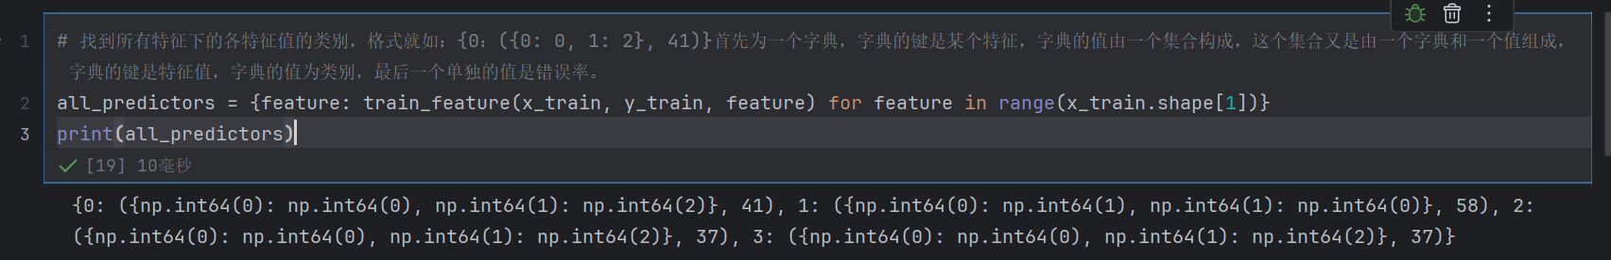

运行代码：
- # 筛选出每个特征下的错误率出来
- errors = {feature: error for feature, (mapping, error) in all_predictors.items()}

- # 找到错误率最低的最佳特征
- best_feature, best_error = sorted(errors.items(), key=itemgetter(1), reverse=False)[0]
- print(f"The best model is based on feature {best_feature} and has error {best_error:.2f}")
- print("Best feature mapping:", all_predictors[best_feature][0])

结果截图：
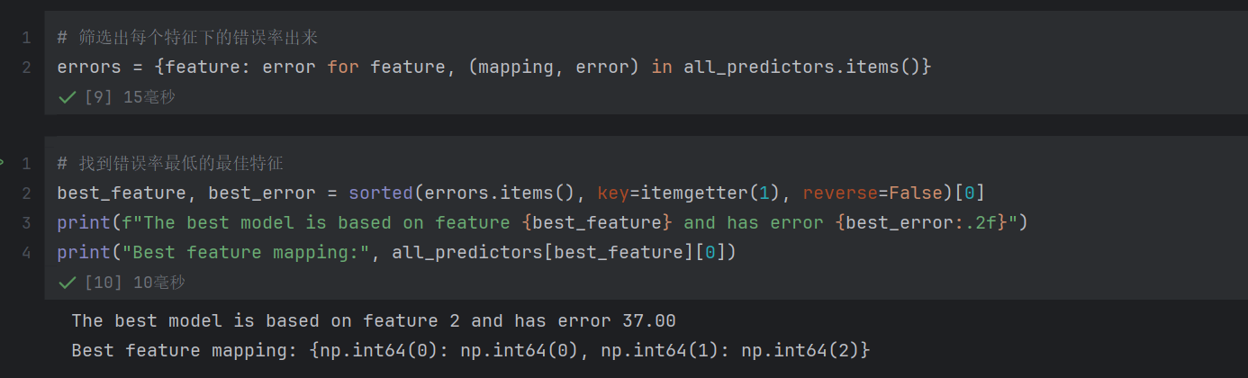

运行代码：

- # 建立模型
- model = {"feature": best_feature, "predictor": all_predictors[best_feature][0]} # 修正引号错误

- # 预测函数
- def predict(x_test, model):
- feature = model["feature"]
- predictor = model["predictor"]
- y_predict = np.array([predictor[int(sample[feature])] for sample in x_test])
- return y_predict

- # 测试模型
- y_predict = predict(x_test, model)

- # 计算准确率
- accuracy = np.mean(y_predict == y_test) * 100
- print(f"The test accuracy is {accuracy:.2f}%")

结果截图：
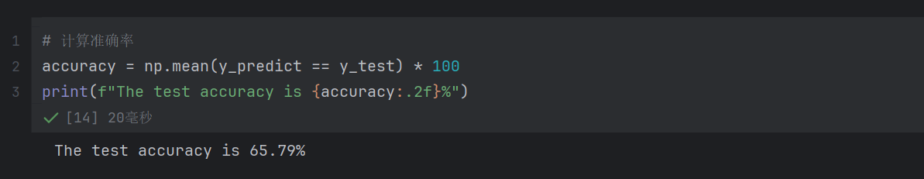

运行代码：

- from sklearn.metrics import classification_report

- # 输出分类报告时添加 zero_division 参数
- print(classification_report(y_test, y_predict, zero_division=1)) # 或 zero_division=0

结果截图：
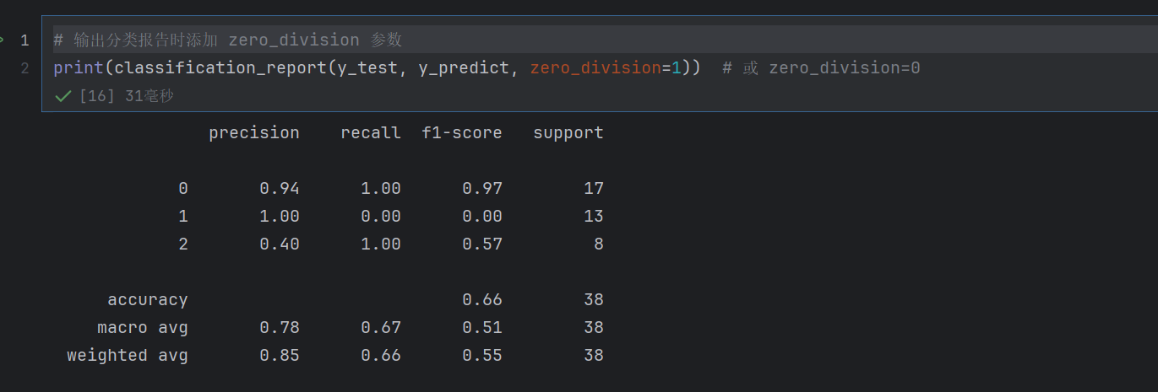

决策树实验
运行代码：
- import pandas as pd
- from sklearn.model_selection import train_test_split
- from sklearn.tree import DecisionTreeClassifier
- from sklearn.metrics import accuracy_score
- from sklearn.tree import plot_tree
- import matplotlib.pyplot as plt

- # 步骤1：加载数据并预处理
- def load_and_preprocess_data(file_path):
- data = pd.read_csv(file_path)
- # 选择需要的列
- selected_columns = ['b', 'gendre', 'age', 'classification of nodule', 'Lobe']
- data = data[selected_columns]
- # 处理缺失值
- data = data.dropna()
- # 对分类变量进行编码
- data_encoded = pd.get_dummies(data, columns=['classification of nodule', 'Lobe'])
- return data_encoded

- # 步骤2：划分训练集和测试集
- def split_data(data_encoded):
- X = data_encoded.drop('b', axis=1)
- y = data_encoded['b']
- X_train, X_test, y_train, y_test = train_test_split(X, y, test_size=0.2, random_state=42)
- return X_train, X_test, y_train, y_test

- # 步骤3：构建决策树模型并训练
- def train_model(X_train, y_train):
- clf = DecisionTreeClassifier(random_state=42)
- clf.fit(X_train, y_train)
- return clf

- # 步骤4：评估模型准确率
- def evaluate_model(clf, X_test, y_test):
- y_pred = clf.predict(X_test)
- accuracy = accuracy_score(y_test, y_pred)
- print(f"模型准确率: {accuracy * 100:.2f}%")

- # 步骤5：可视化决策树
- def visualize_tree(clf, feature_names):
- plt.rcParams['figure.dpi'] = 300
- plt.figure(figsize=(12, 8))
- plot_tree(clf, filled=True, feature_names=feature_names, class_names=clf.classes_)
- plt.show()

- # 步骤6：从决策树中提取规则
- def tree_to_rules(tree, feature_names):
- from sklearn.tree import _tree

- tree_ = tree.tree_
- feature_name = [
- feature_names[i] if i != _tree.TREE_UNDEFINED else "undefined!"
- for i in tree_.feature
- ]

- def recurse(node, previous_rules):
- if tree_.feature[node] != _tree.TREE_UNDEFINED:
- name = feature_name[node]
- threshold = tree_.threshold[node]
- left_rules = previous_rules + [f"({name} <= {threshold})"]
- recurse(tree_.children_left[node], left_rules)
- right_rules = previous_rules + [f"({name} > {threshold})"]
- recurse(tree_.children_right[node], right_rules)
- else:
- class_index = np.argmax(tree_.value[node])
- class_label = tree.classes_[class_index]
- rule = " & ".join(previous_rules)
- print(f"如果 {rule}, 那么 病灶类型为 {class_label}")

- recurse(0, [])

- if __name__ == "__main__":
- file_path = "C:/Users/21626/Downloads/train.csv"
- data_encoded = load_and_preprocess_data(file_path)
- X_train, X_test, y_train, y_test = split_data(data_encoded)
- clf = train_model(X_train, y_train)
- evaluate_model(clf, X_test, y_test)
- visualize_tree(clf, X_train.columns)
- print("\n决策树规则:")
- tree_to_rules(clf, X_train.columns)

结果截图：
